# **Bootstrap**

Dynamic styling framework for html

[Download · Bootstrap v4.5 (getbootstrap.com)](https://getbootstrap.com/docs/4.5/getting-started/download/)

Youtube: [Bootstrap 5 tutorial - crash course for beginners in 1.5H (stable release May 2021) - YouTube](https://www.youtube.com/watch?v=rQryOSyfXmI&list=PLl1gkwYU90QlfX9oIJvC4JJKaucei7Hx8&t=0s&ab_channel=Keepcoding)

Concepts

We add classes to our elements to make use of the front end framework features

**For example:**

<ul class=”list-inline”>

<img class=”img-fluid” src=”https:… />

# **What is Bootstrap:**

Increases development speed:

* Is already tested and verified by other users. Over 18 million users

Responsiveness & Mobile first approach:

* Can reuse elements in different projects and designed for mobile development

Tested:

* It is tested regularly for new web browsers and mobile devices

Large community:

* Large community for asking questions

# **Bootstrap 5 vs 4**

**No major changes in components**

**Much better organised, modular and easily customisable, lightweight**

* jQuery not required anymore (you can use it if you want)
* Internet Explorer not supported
* RTL (right to left) Support
* JavaScript minimised, in favor of CSS (CSS custom properties)
  + Which means it is more light weight
* Almost all option is available as data attribute
  + Everything
* Grid system, modularity, customisation
* New components (offcanvas)
* Some components were removed (jumbotron)
* Enhanced Icons

# **Bootstrap Components**

## **Grid System:**

Grid is what makes Bootstrap unique and is the most important component of bootstrap for designing your page.

It allows us to create responsive layouts and rearrange it according to the screen size. I.e. it will be responsive to both desktop and mobile layout.

You don’t have to have separate domain names for mobile and desktop (i.e. m.facebook vs facebook.com)

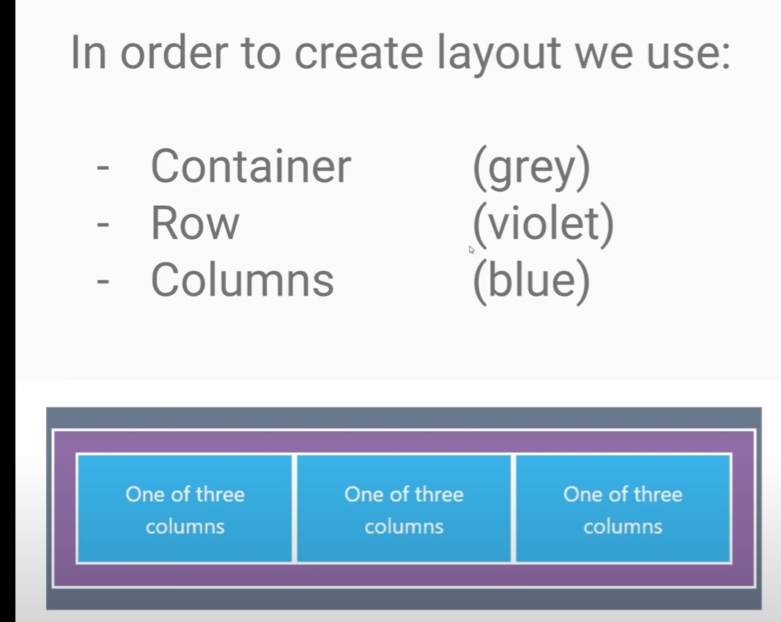

## **Breakpoints**

Allows us to create different sizes for each element and components. Breakpoints will resize the element depending on the size of the browser. I.e. minimising the width of the browser will

minimise the component. When it hits the breakpoint the component will change, such as moving the sidebar below or hiding it.

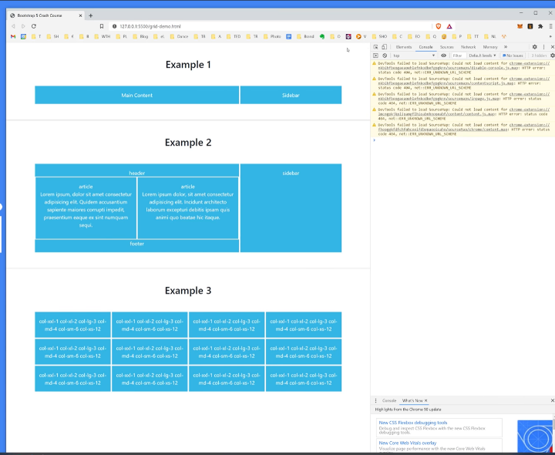

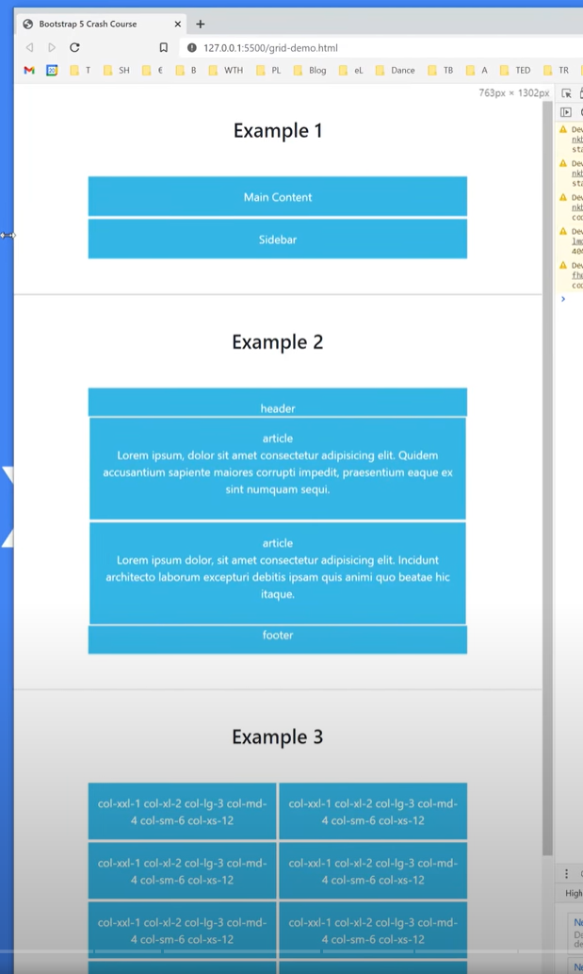

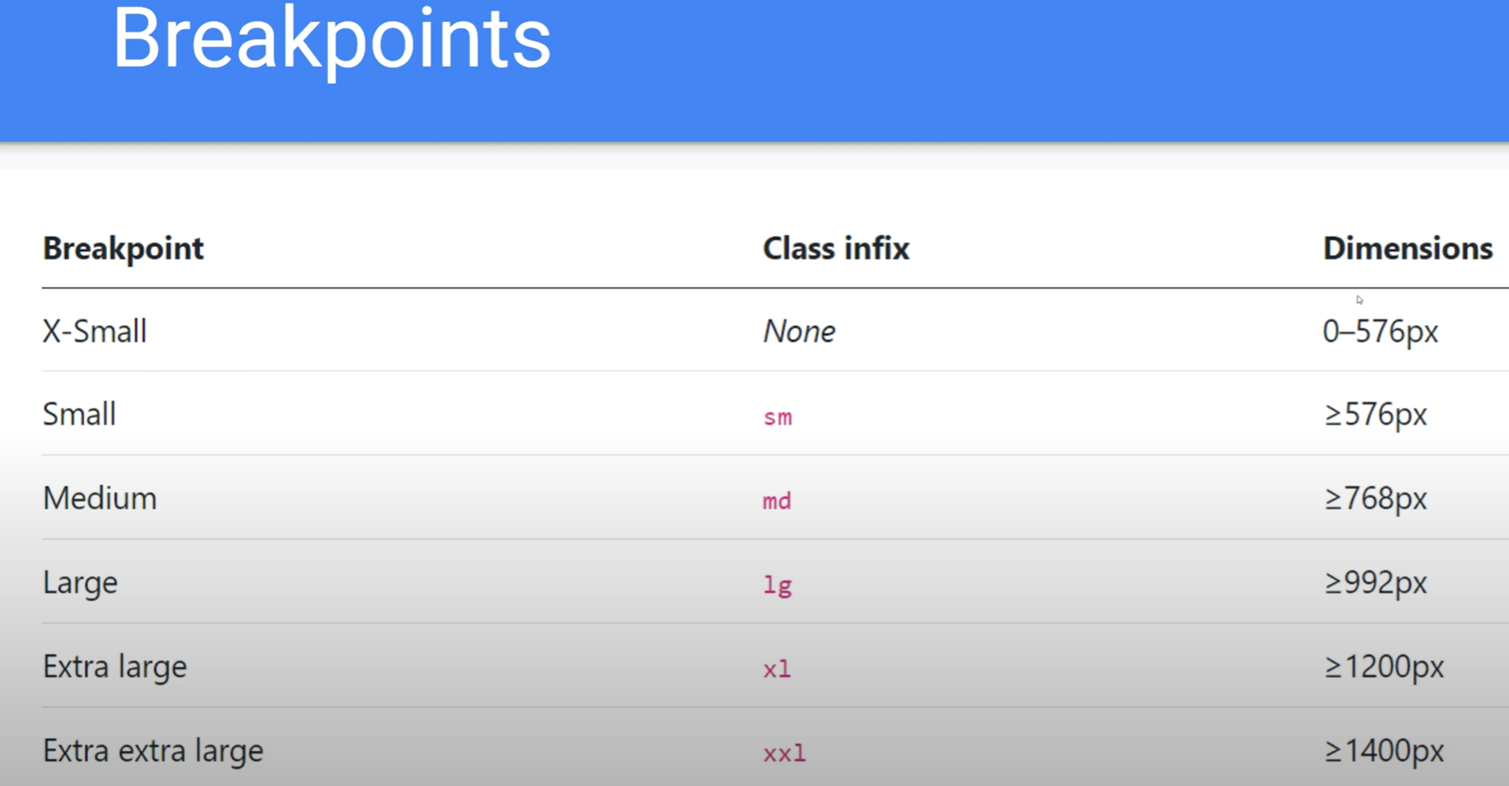

## **Columns : sizes and widths**

Col-xxl-1 means that for xxl large screens there will be 1 “box” per column, so 12 columns in a row.

Col-xs-12 means that om xs small screens there will be 12 “boxes” in 1 column. So 1 columns with all the “boxes”.

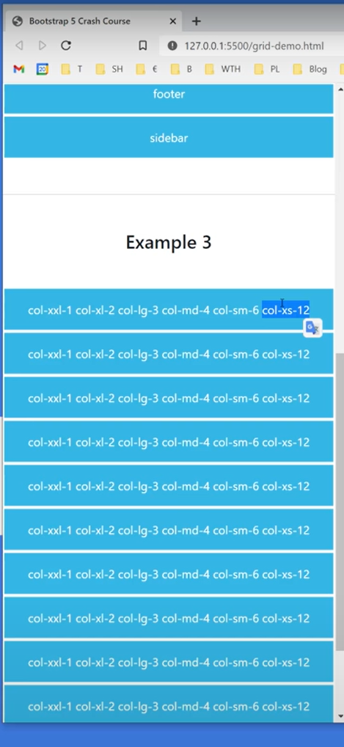

## **Columns: Gutter class: Adding white space between columns (horizontally or vertically)**

<div class=”row g-5” means that a margin size of 5 will be added between each column.

This gutter class will wrap around all the other columns and add the margin.

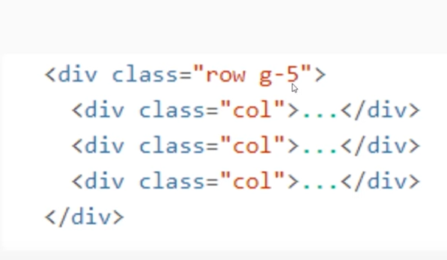

# **Layout Hierarchy – Container, Row, Column**

## **Container <div class=container>**

### **Container centrally located – without breakpoint**

<div class=container> Will centre the container and not take the full width of the screen (suitable for desktop)

### **Columns with fluid – responsive auto width scaling**

<div class=container-fluid> Will take the full width of the screen (suitable for mobile)

### **Combining Container with breakpoints (responsive containter)**

<div class=container-md> Means the container will resize according to the size of the screen, in this case medium pixel size >= 768px. So the container will be centralised until the breakpoint is hit due to the screen size being medium or less.

## **Row <div class=row>**

Try keep the rows so it sums up the columns to 12.

## **Columns <div class=col>**

### **Columns without break point (auto scale width)**

<div class=col> Meaning that this column has no defined width or break point. So the columns will stay the same size and auto scale in width and size

### **Columns with break point**

<div class=col-sm> Meaning that when the break point is hit the columns will separate to individual columns, or into a single column.

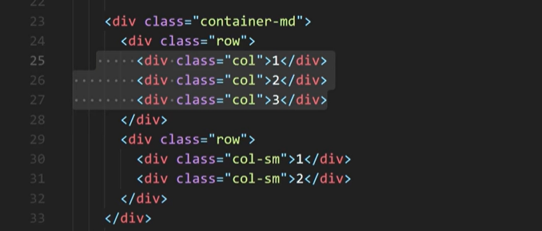

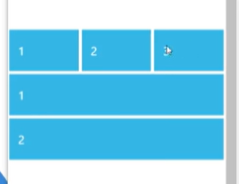

### **Columns with breakpoint and pixel size**

<div class=col-md-8> Meaning this column has a breakpoint of medium size screen and a column width size of 8

<div class=col-md-4> Meaning this column has a breakpoint of medium size screen and a column width size of 4.

Bootstrap will maintain the size ration between these columns when you resize the width of the screen.

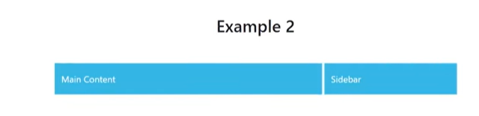

### **Columns with mixed sizes and breakpoints**

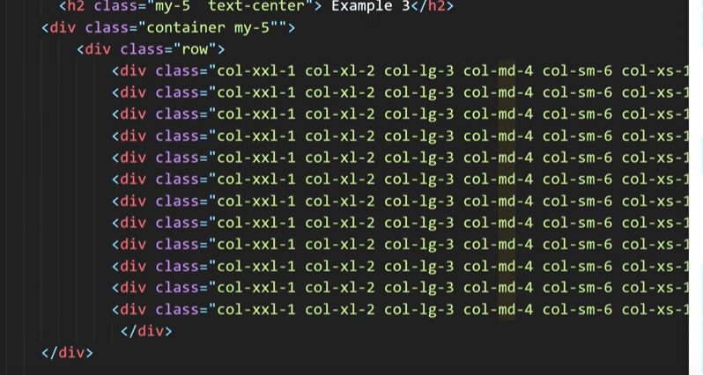

Columns with gutters

Allows us to work with white spacing between rows and columns. Gutter has an x axis and y axis (horizontal and vertical).

Gutter spacing range is from 0 -5.

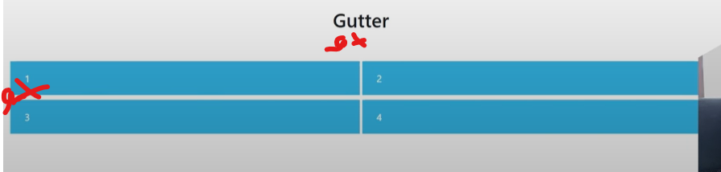

<div class=”row gx-0”> Meaning that the vertical spacing of each row has no spacing vertically between the rows.

<div class”row gy-5”> Meaning that the horizontal spacing is 5.

<div class=row gx-0 gy-5> Meaning that the white space is 0 for vertical and 5 for horizontal

<div class=row g-5> Meaning that the white space is 5 for vertical (gx) and horizontal (gy)

# **2. Components**

## **1. Buttons**

### **Button Types and classes**

When creating buttons you need to define the component type “button” and the button class “ptn-primary”. The component type (type=button) is the parent for the component child (class=btn-primary).

Button come with default colours for each button class, primary and secondary.

### **Button Outline**

Button without background colour, only the outline border colour.

### **Button Groups**

Allows you to group butons next to each other

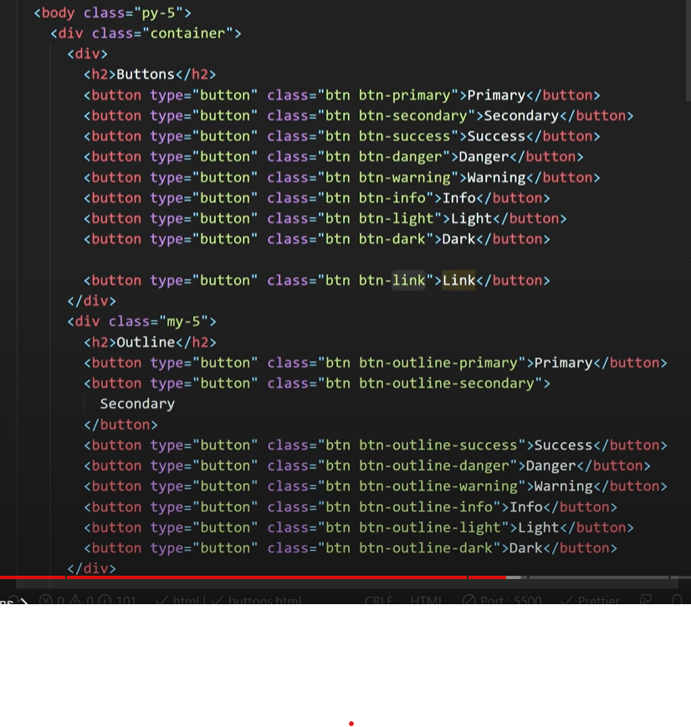

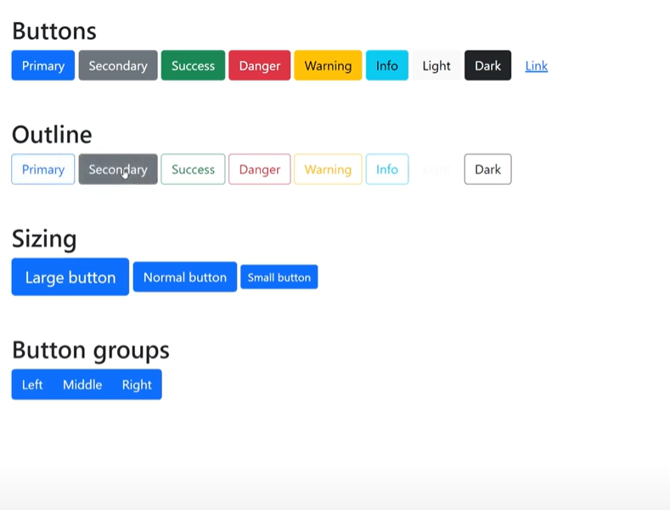

## **2. Cards**

Cars wraps around a content of text. The cards will be a child of the column class, which is a child of the row class.

<div class=”my-5”>

<div class=”col-sm-6”> Column size of six with small breakpoint

<div class=”card”> The column only holds a single card, which controls the size of the card.

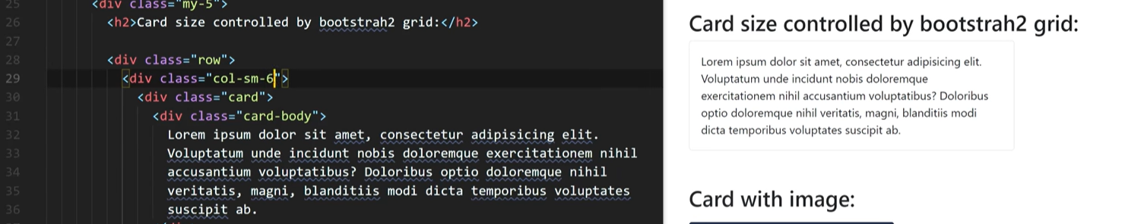

The cards can have shadow, and other features.

### **Card with image**

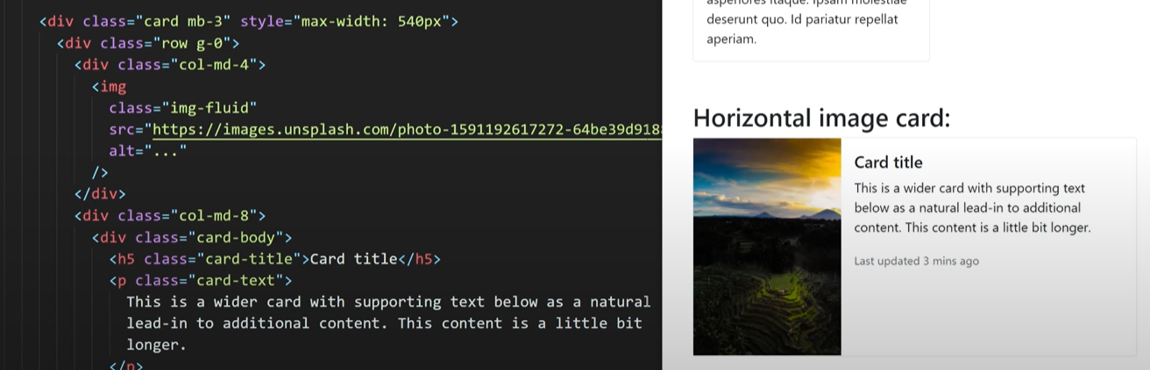

### **Card with border**

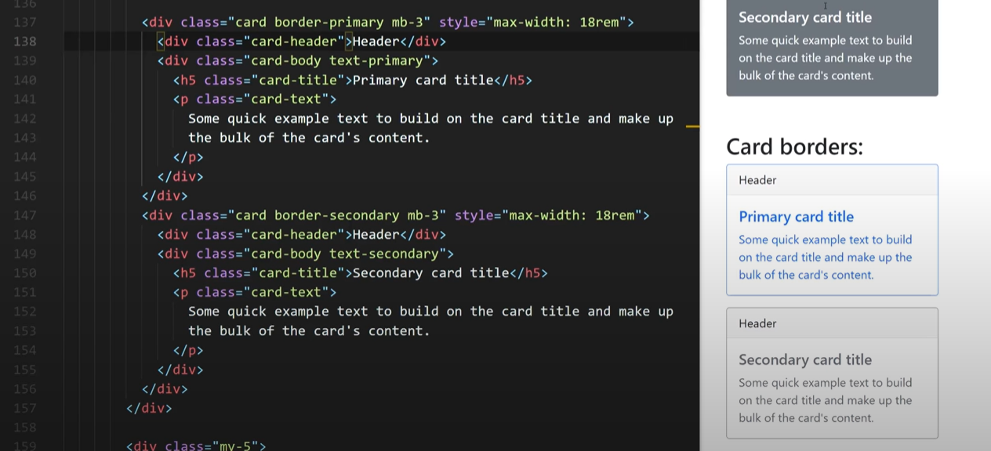

### **Card group**

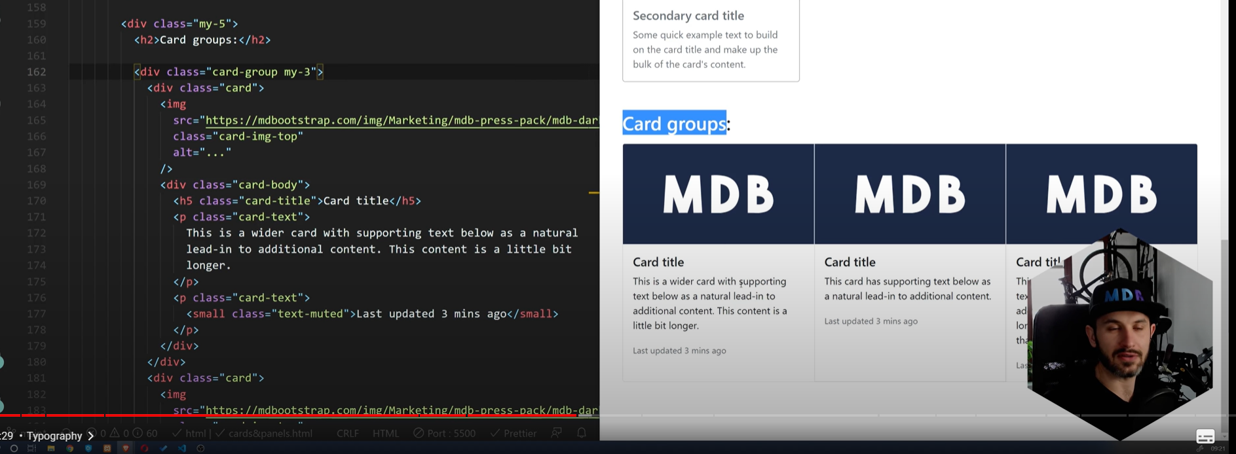

# **Typography**

**Bootstrap documentation – Text Utilities:**

[Text · Bootstrap v5.1 (getbootstrap.com)](https://getbootstrap.com/docs/5.1/utilities/text/)

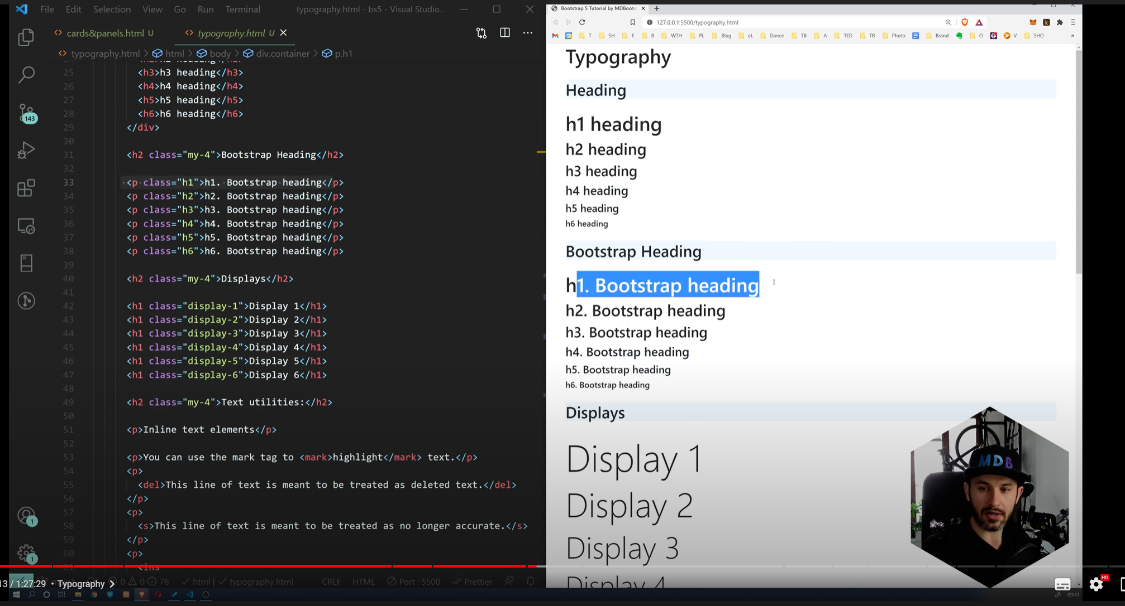

## **Paragraph (p) that looks like heading (but is not of class heading h1)**

<p class=”h1”>h1. Bootstrap heading </p> Meaning element of type paragraph (p) of class heading (h1).

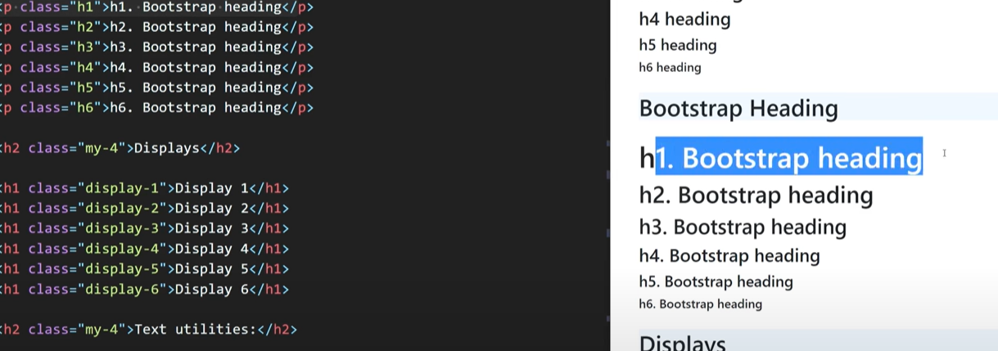

## **Display Classes**

Changes the look of an element

<h1 class=”display-1”> </h1> Meaning header element of type h1, has a display class of display-1

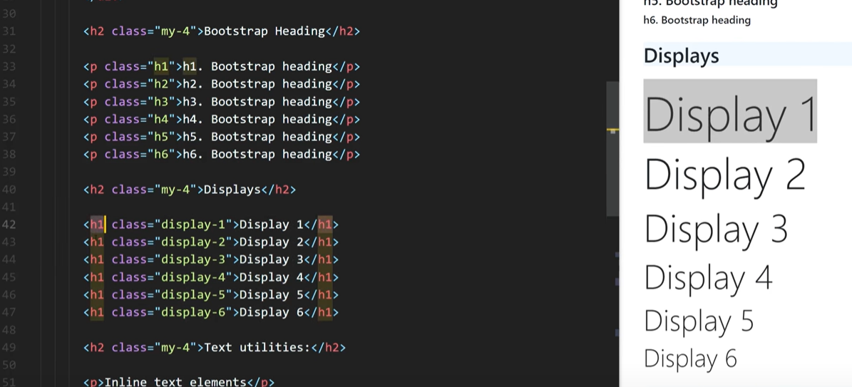

## **Text utilities**

Changes the design of the text font

<p>Inline text element</p>

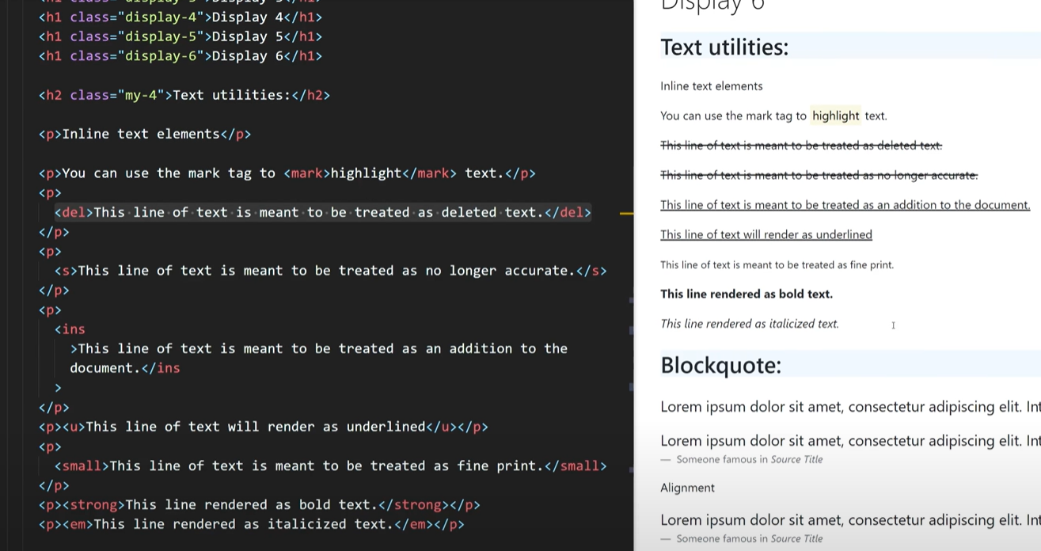

## **Blockquote:**

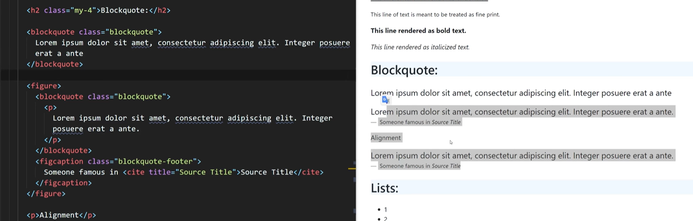

## **Lists**

Unordered lists and unstyled lists without any bullet points and inline lists

### **Unordered lists with sub list**

<ul class=””>

<li>1</li>

<ul>

<li>1</li>

</ul>

</ul>

### **Unordered list without bullet points**

<ul class=”list-unstyled”>

<li>1</li>

<ul>

<li>1</li>

</ul>

</ul>

## **Unordered inline list (horizontal list)**

<ul class=”list-inline”>

<li>1</li>

<li>2</li>

</ul>

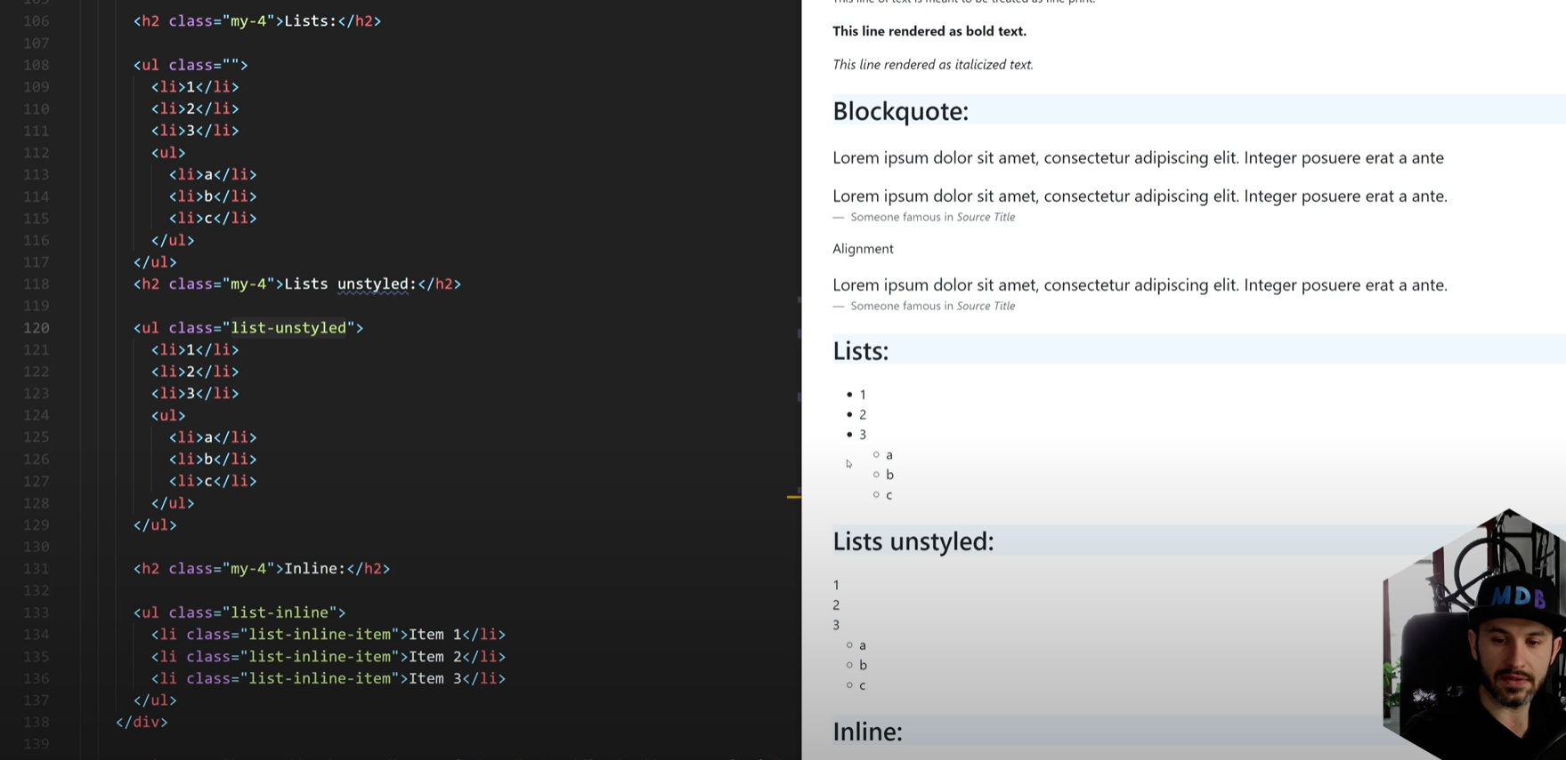

# **Responsive Images**

**Images bootstrap doc:** [Images · Bootstrap v5.1 (getbootstrap.com)](https://getbootstrap.com/docs/5.1/content/images/)

## **Img-fluid class**

Allows the image to be responsive and scale the width according to the screen size automatically.

<img

Class=”img-fluid”

Src:”https:”

/>

## **Clearfix and Float**

Docs: [Clearfix in Bootstrap - GeeksforGeeks](https://www.geeksforgeeks.org/clearfix-in-bootstrap/)

Bootstrap: [Clearfix · Bootstrap v5.1 (getbootstrap.com)](https://getbootstrap.com/docs/5.1/helpers/clearfix/)

When you use float you have to use clearfix helper, which makes sure text and other content does not wrap around the image.

<div class=”clearfix my-5”></div>

**Before**

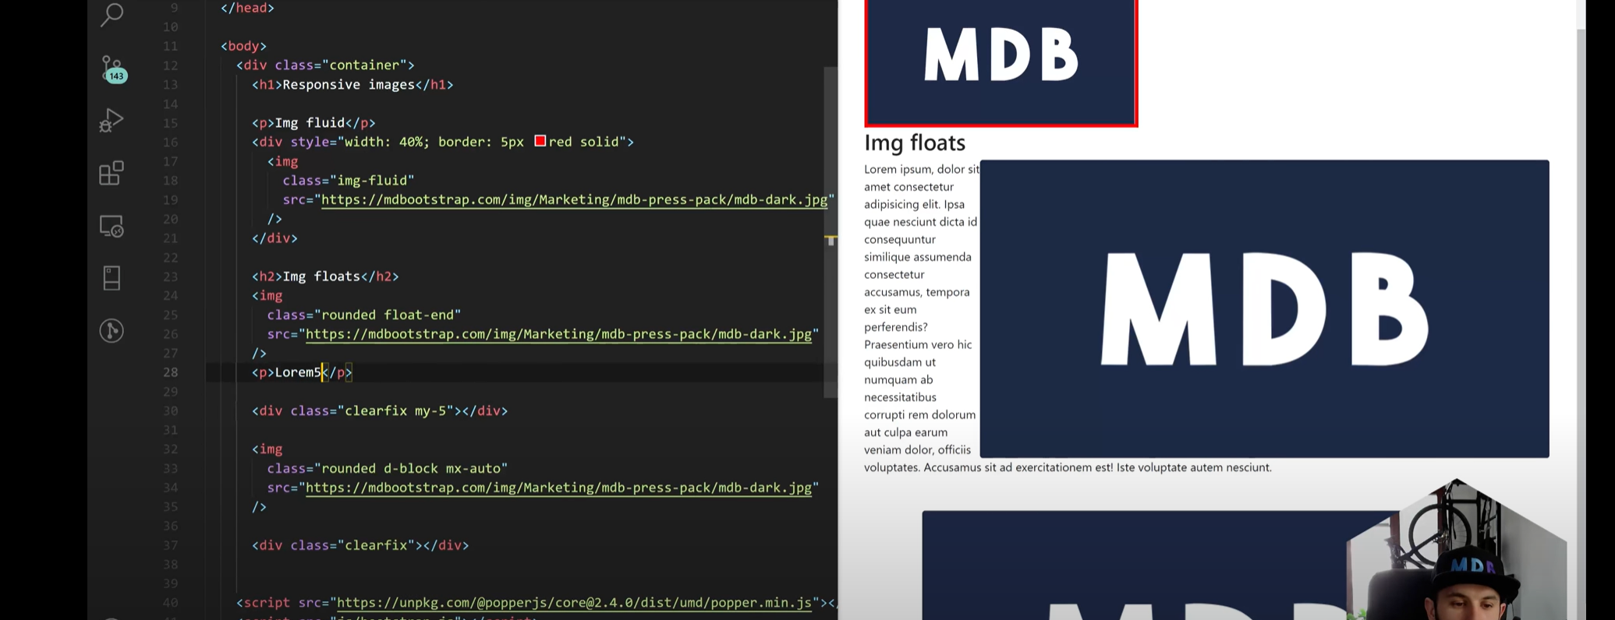

**After**

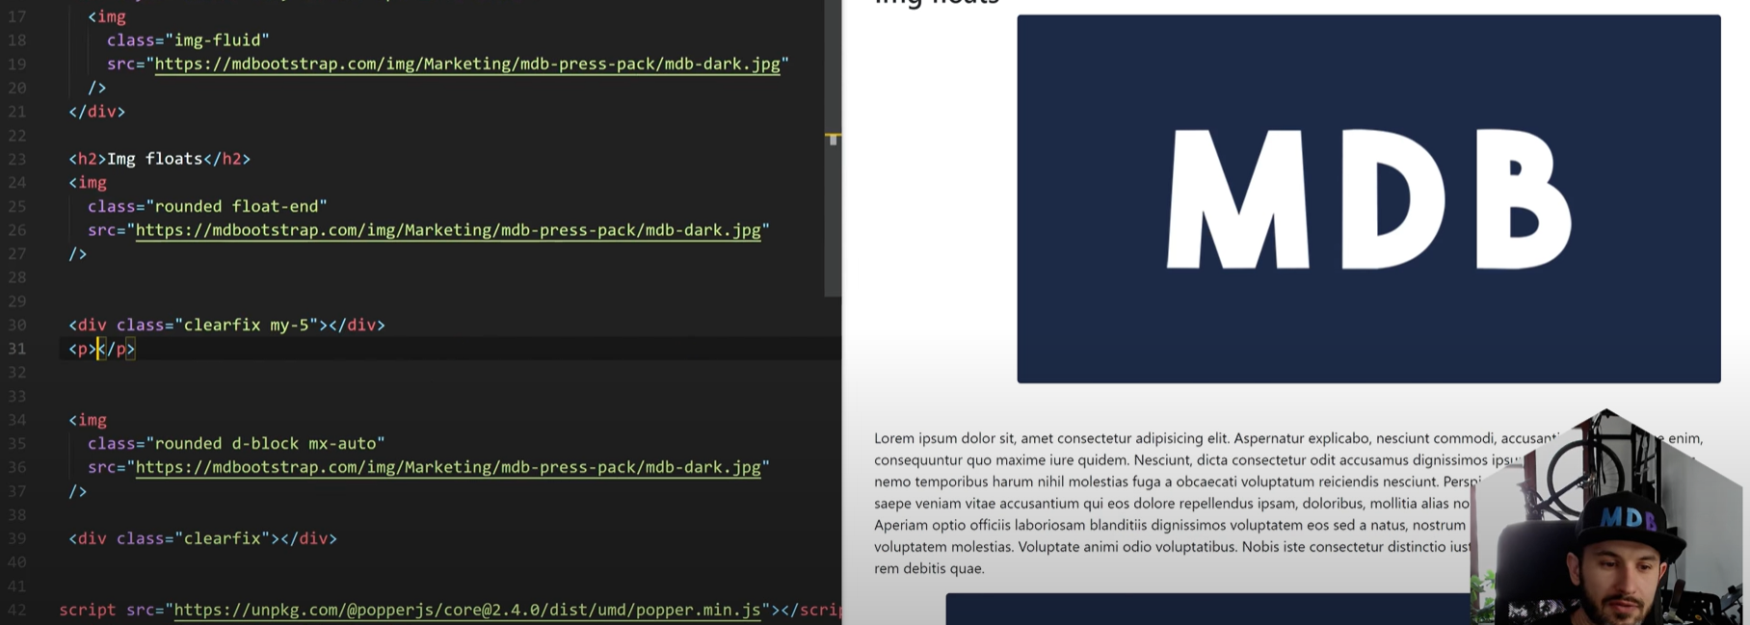

## **Image float**

Allows the text to float around the image

<img

Class=”rounded float-end”

Src:”https:”

/>

## **Image rounded corners float**

Makes the corners of the image rounded

<img

Class=”rounded float-end”

Src:”https:”

/>

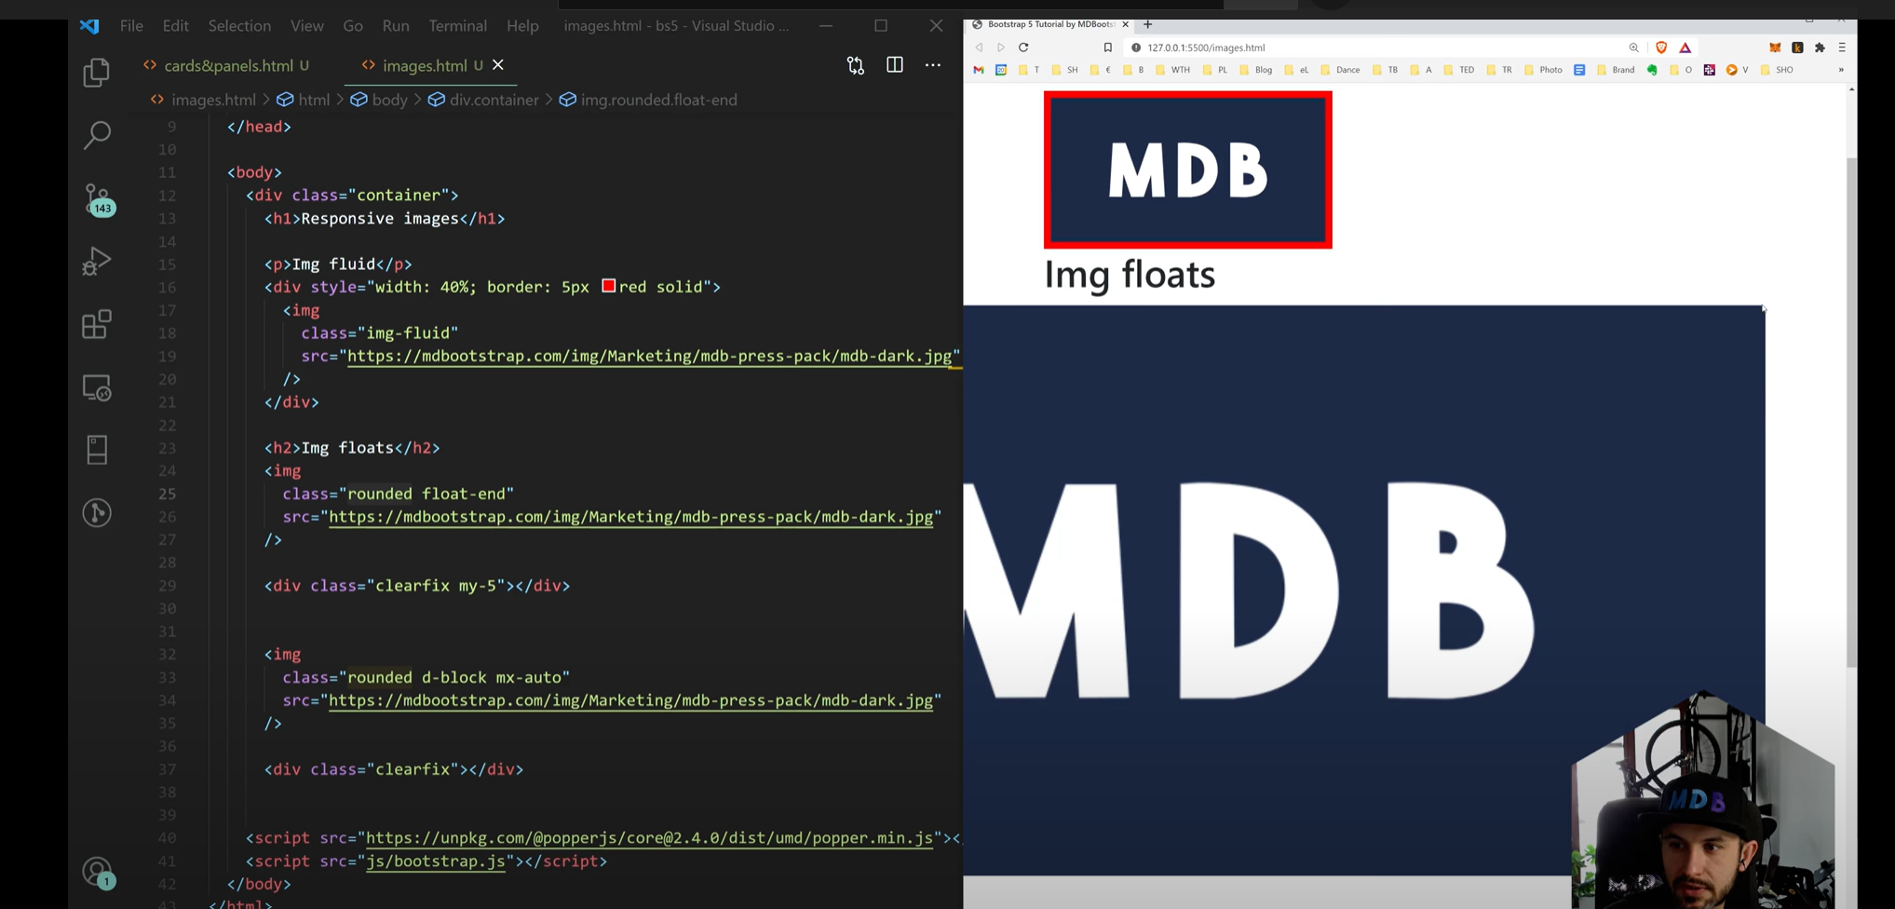

### **Cantering Images**

Mx-auto sets margin right and margin left to automatic

<img

Class=”rounded d-block mx-auto**”** **Meaning rounded image with margin right and left to auto**

Src=”https:”

/>

# **Utilities (Margin and Padding)**

## **Spacing Utilities (Margin and Padding)**

Docs: [Spacing · Bootstrap v5.1 (getbootstrap.com)](https://getbootstrap.com/docs/5.1/utilities/spacing/)

Responsive margin, padding and gap utility classes to modify an elements appearance.

You can change the value of the spacing, and choose from what direction it will start.

You can also choose the spacing type, margin or padding.

Where property is one of:

* m - for classes that set margin
* p - for classes that set padding

Where sides is one of:

* t - for classes that set margin-top or padding-top
* b - for classes that set margin-bottom or padding-bottom
* s - (start) for classes that set margin-left or padding-left in LTR, margin-right or padding-right in RTL
* e - (end) for classes that set margin-right or padding-right in LTR, margin-left or padding-left in RTL
* x - for classes that set both *-left and *-right
* y - for classes that set both *-top and *-bottom
* blank - for classes that set a margin or padding on all 4 sides of the element

Where size is one of:

* 0 - for classes that eliminate the margin or padding by setting it to 0
* 1 - (by default) for classes that set the margin or padding to $spacer * .25
* 2 - (by default) for classes that set the margin or padding to $spacer * .5
* 3 - (by default) for classes that set the margin or padding to $spacer
* 4 - (by default) for classes that set the margin or padding to $spacer * 1.5
* 5 - (by default) for classes that set the margin or padding to $spacer * 3
* auto - for classes that set the margin to auto

(You can add more sizes by adding entries to the $spacers Sass map variable.)

**Simple explanation of padding:**

<div

Class=”ps-1 pe-5 pt-3 pb-5”

<p>

Lorem

</p>

</div>

**Explanation of customer box shape with margin**

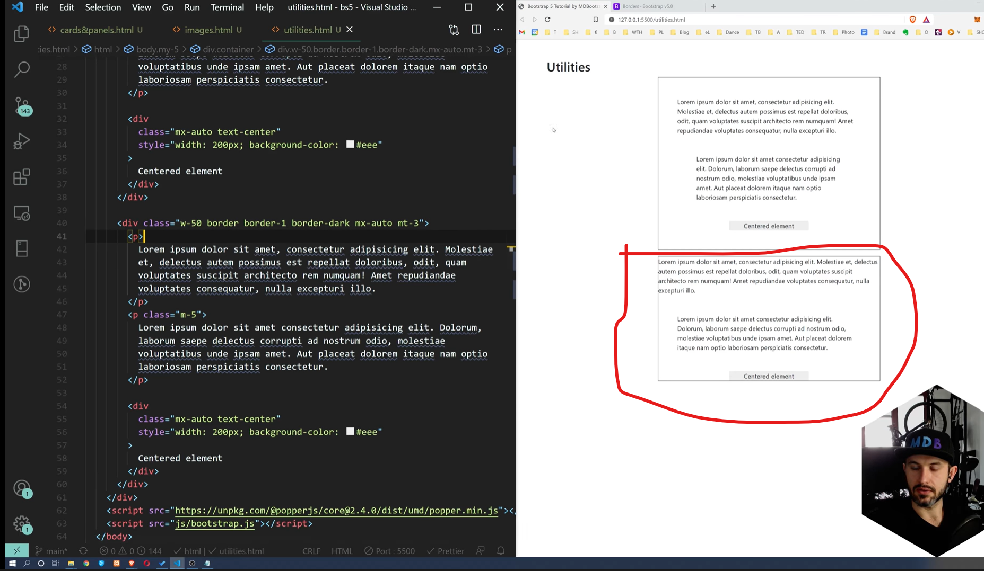

## Background Colour Utility

## Border Colour Utility

## Display Utility

## Flex Utility

## Interactions

# **Tables (Content)**

Docs: [Tables · Bootstrap v5.1 (getbootstrap.com)](https://getbootstrap.com/docs/5.1/content/tables/)

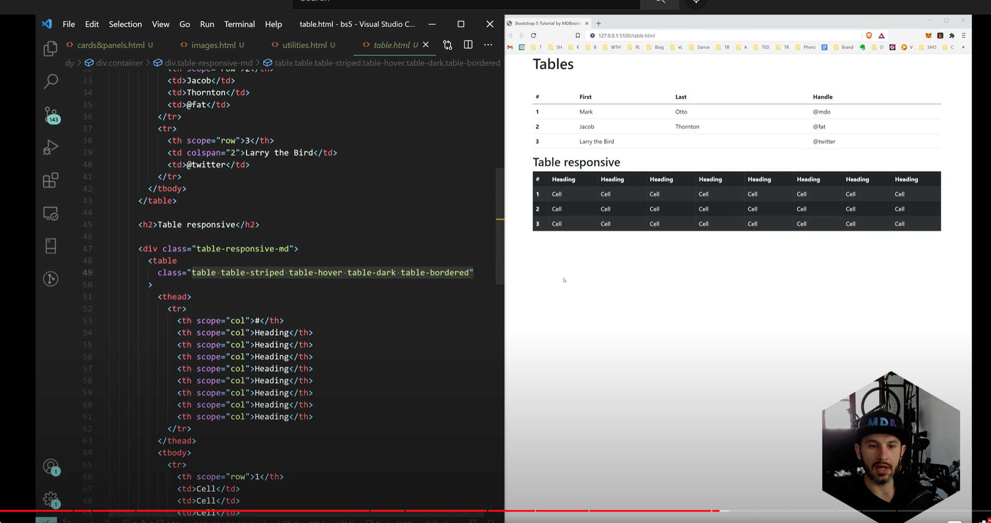

# **Alerts (Components)**

Docs: [Alerts · Bootstrap v5.1 (getbootstrap.com)](https://getbootstrap.com/docs/5.1/components/alerts/)

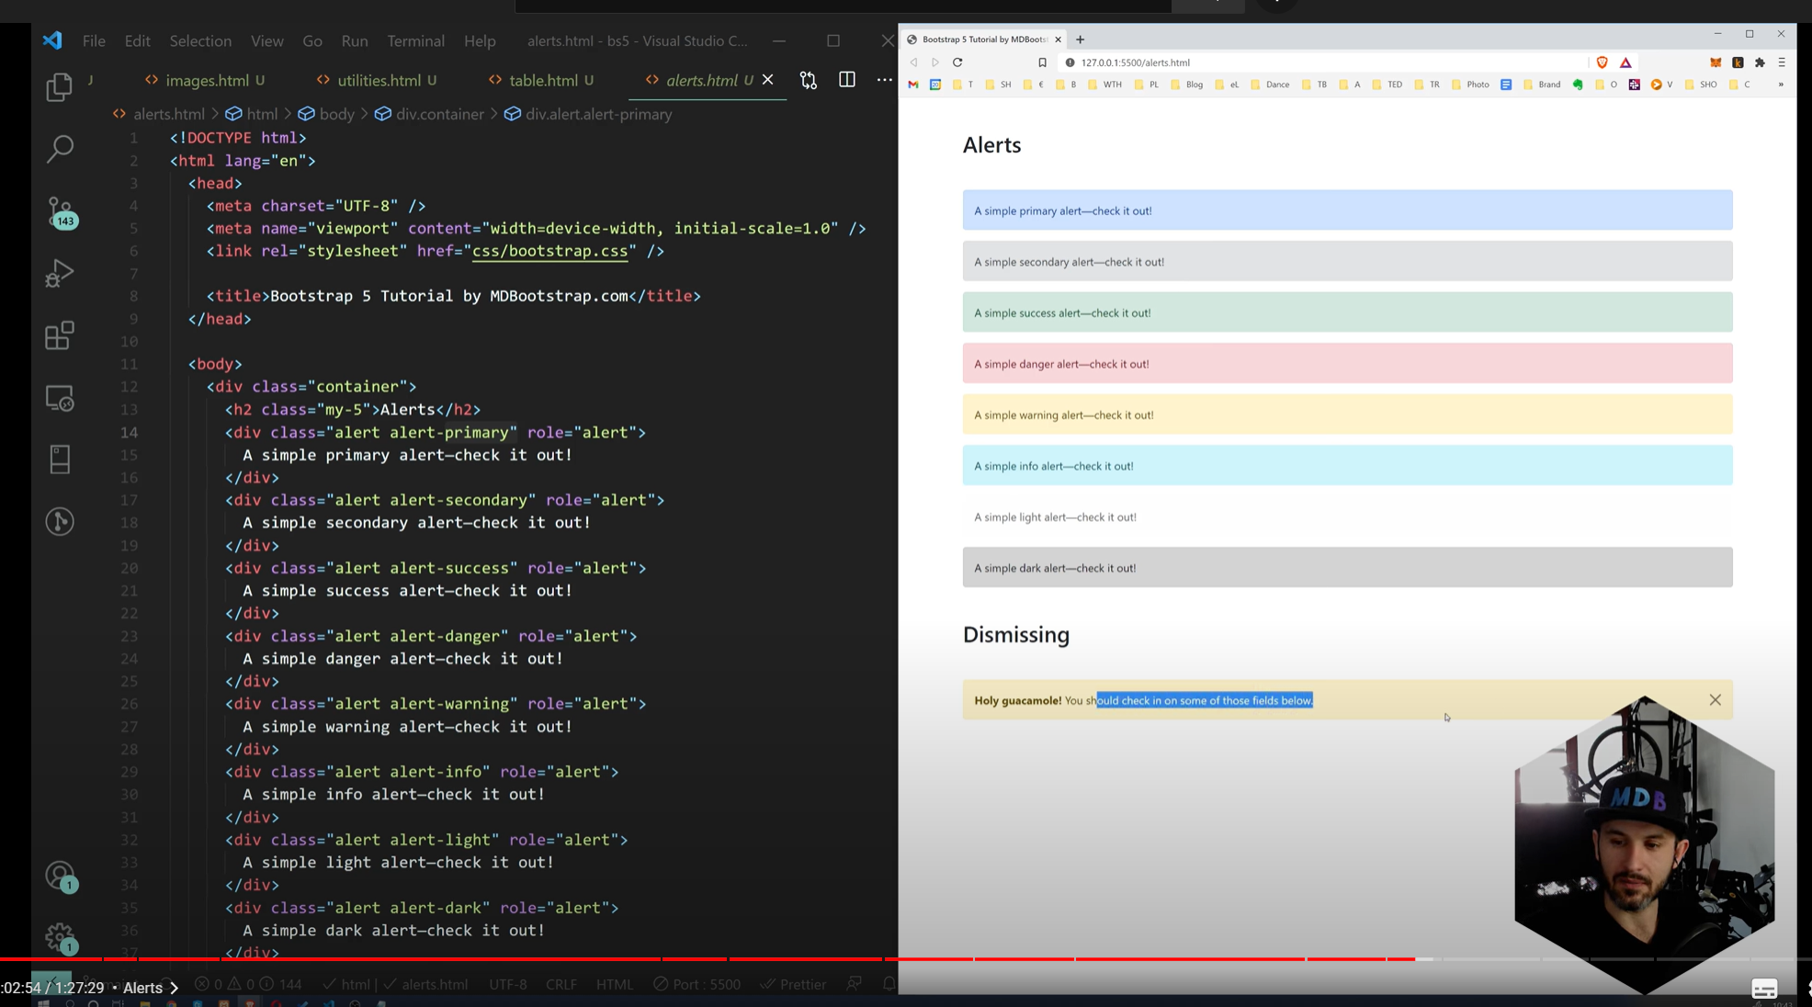

# **Toasts (Components) – Complicated need to read**

Docs: [Toasts · Bootstrap v5.1 (getbootstrap.com)](https://getbootstrap.com/docs/5.1/components/toasts/)

Notifications a lightweight customisable alert message.

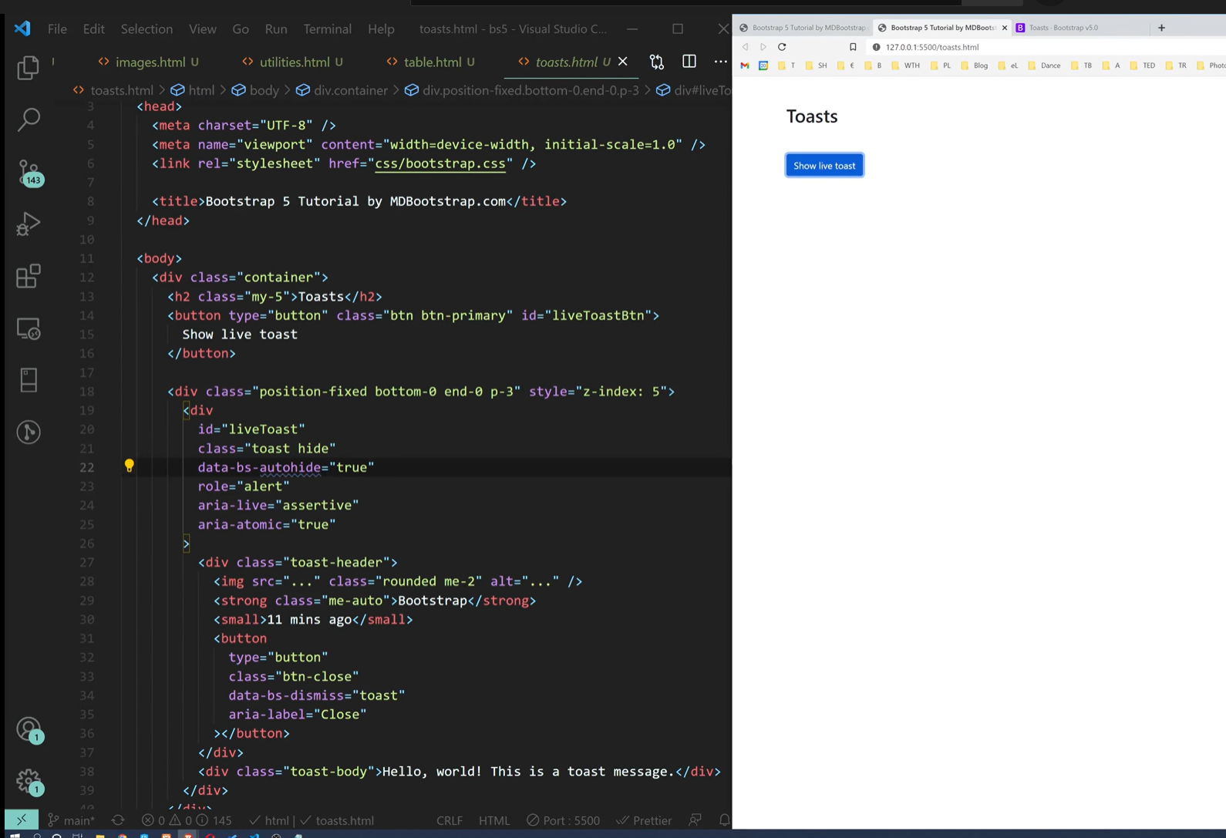

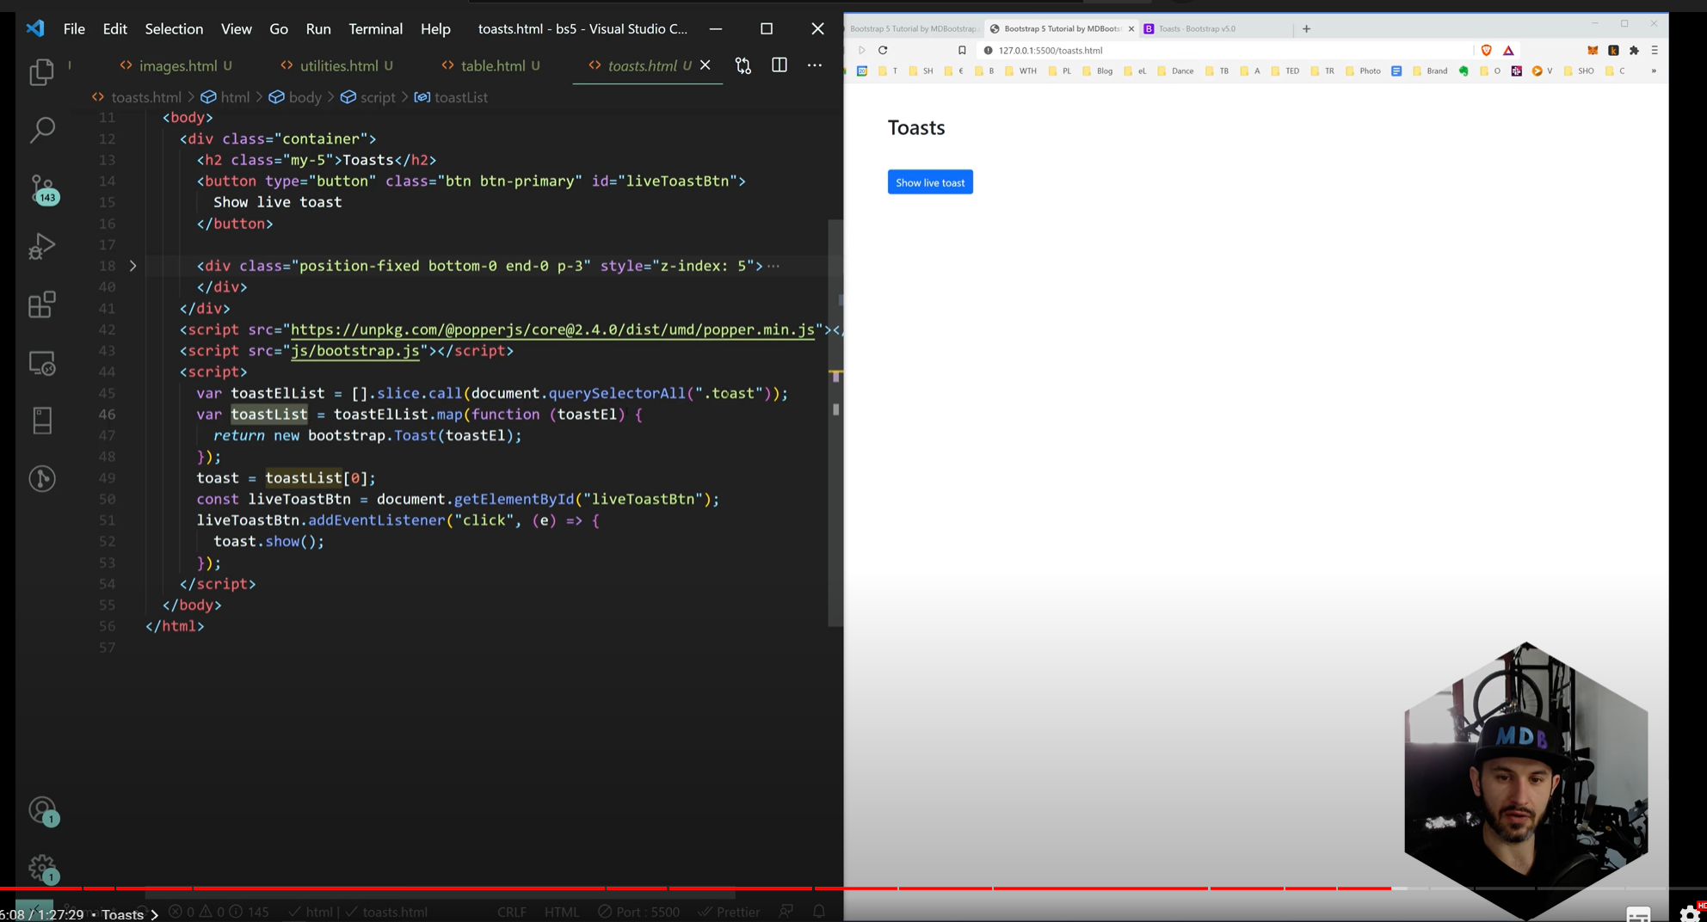

# **Carousel (Component) – Good for displaying images**

Docs: [Carousel · Bootstrap v5.1 (getbootstrap.com)](https://getbootstrap.com/docs/5.1/components/carousel/)

Slider of images, or other content

# **Scroll Spy (Component) – Need to read again**

Tells you where you are when you are scrolling through content

Important concept is ID, content and database spy scroll

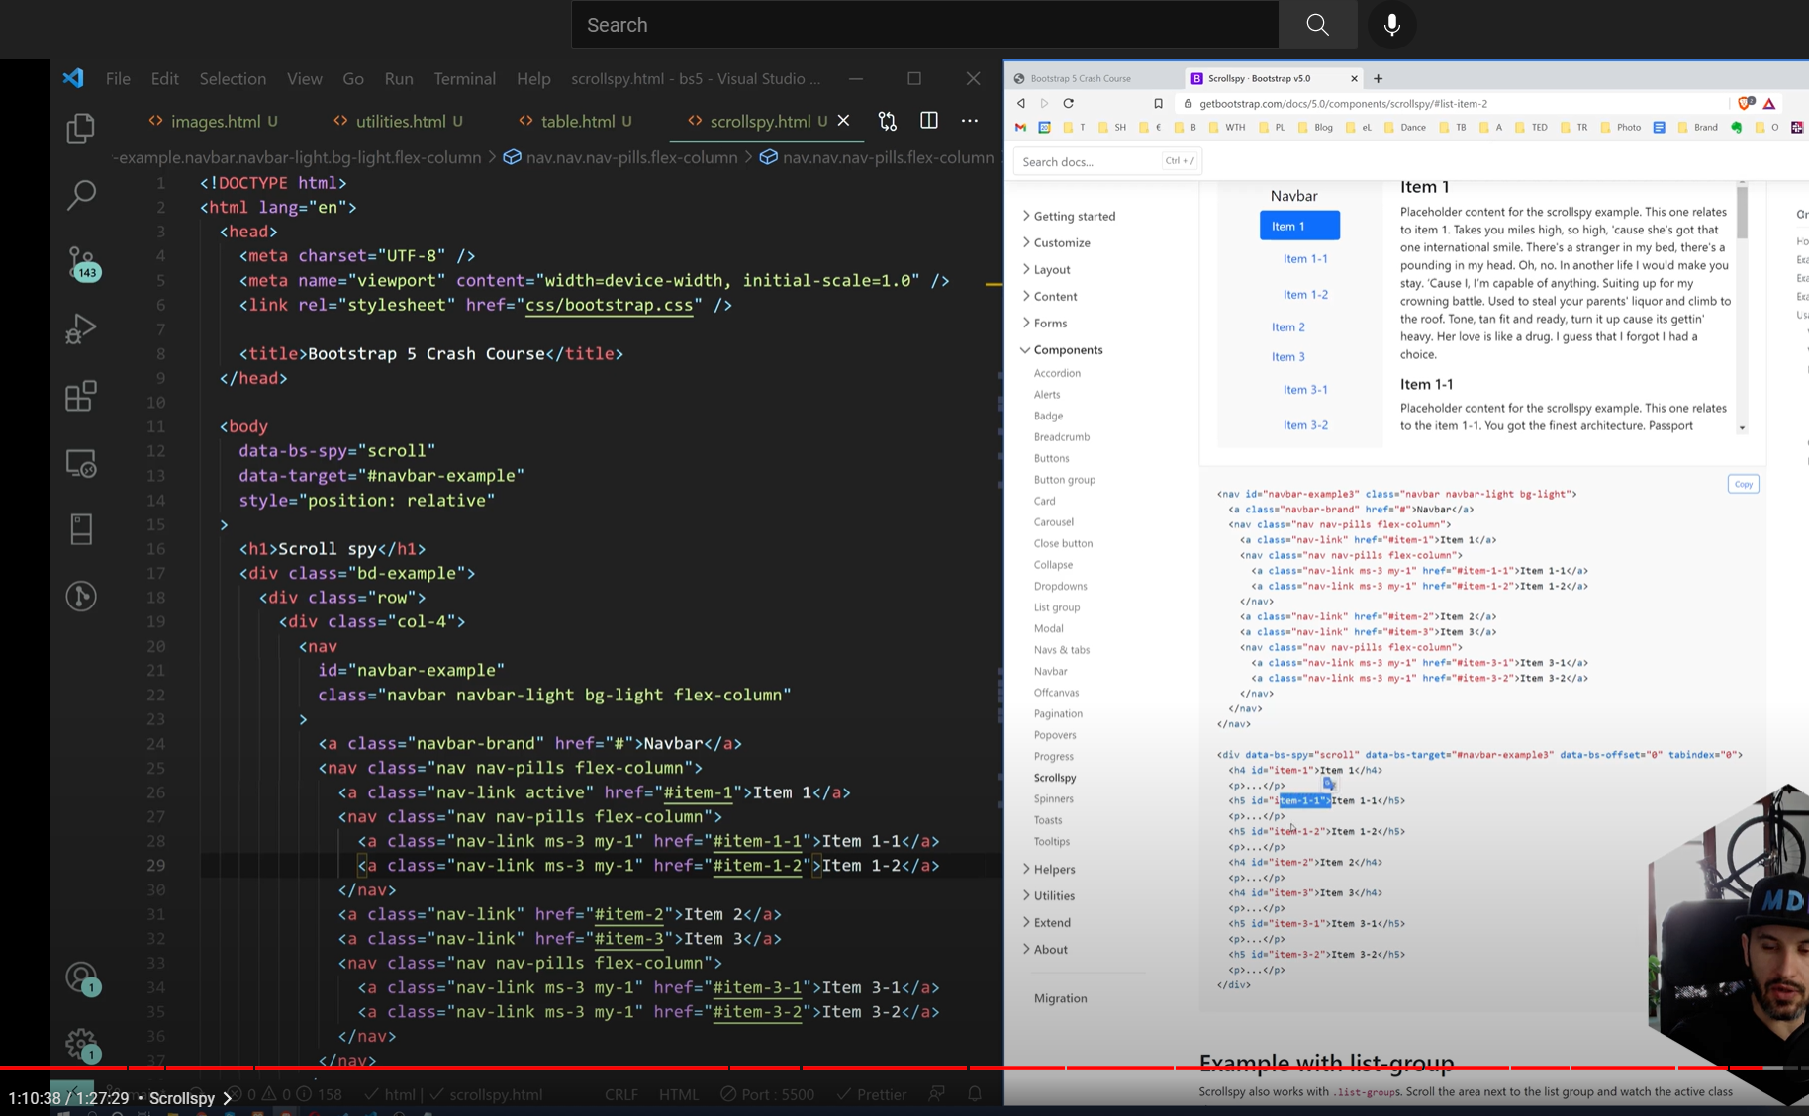

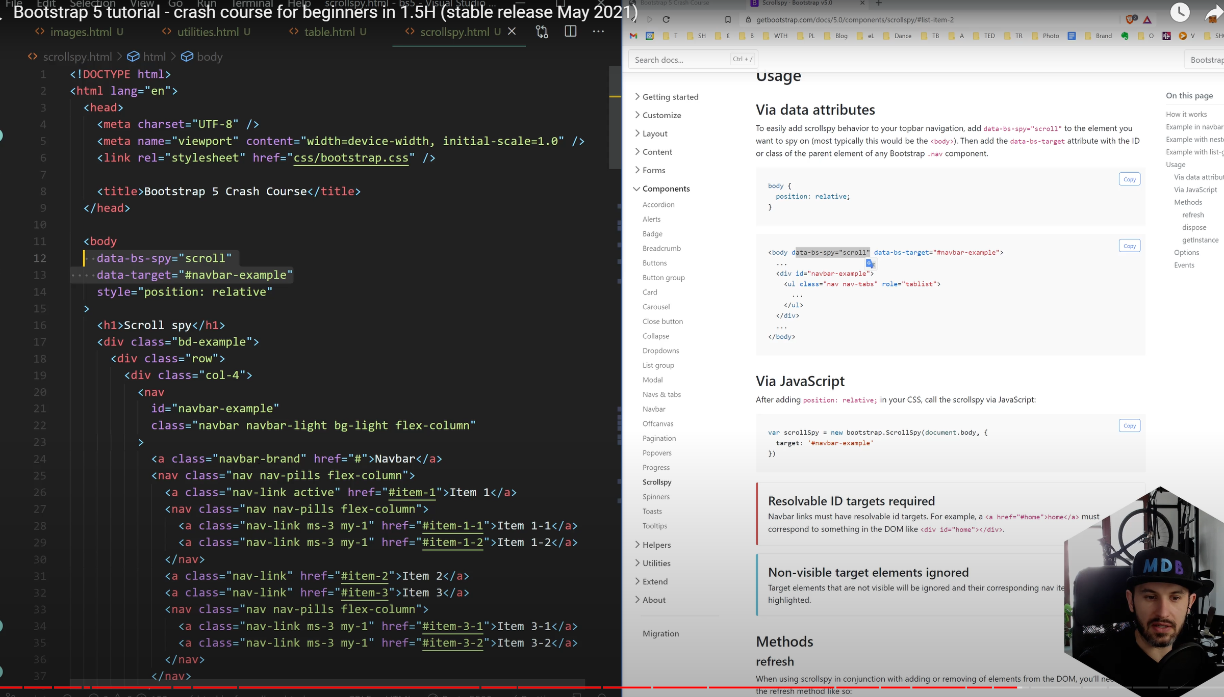

# **Navbars (Component) – Very popular bootstrap**

Responsive navbar, so that when you minimse the screen the navbar will change

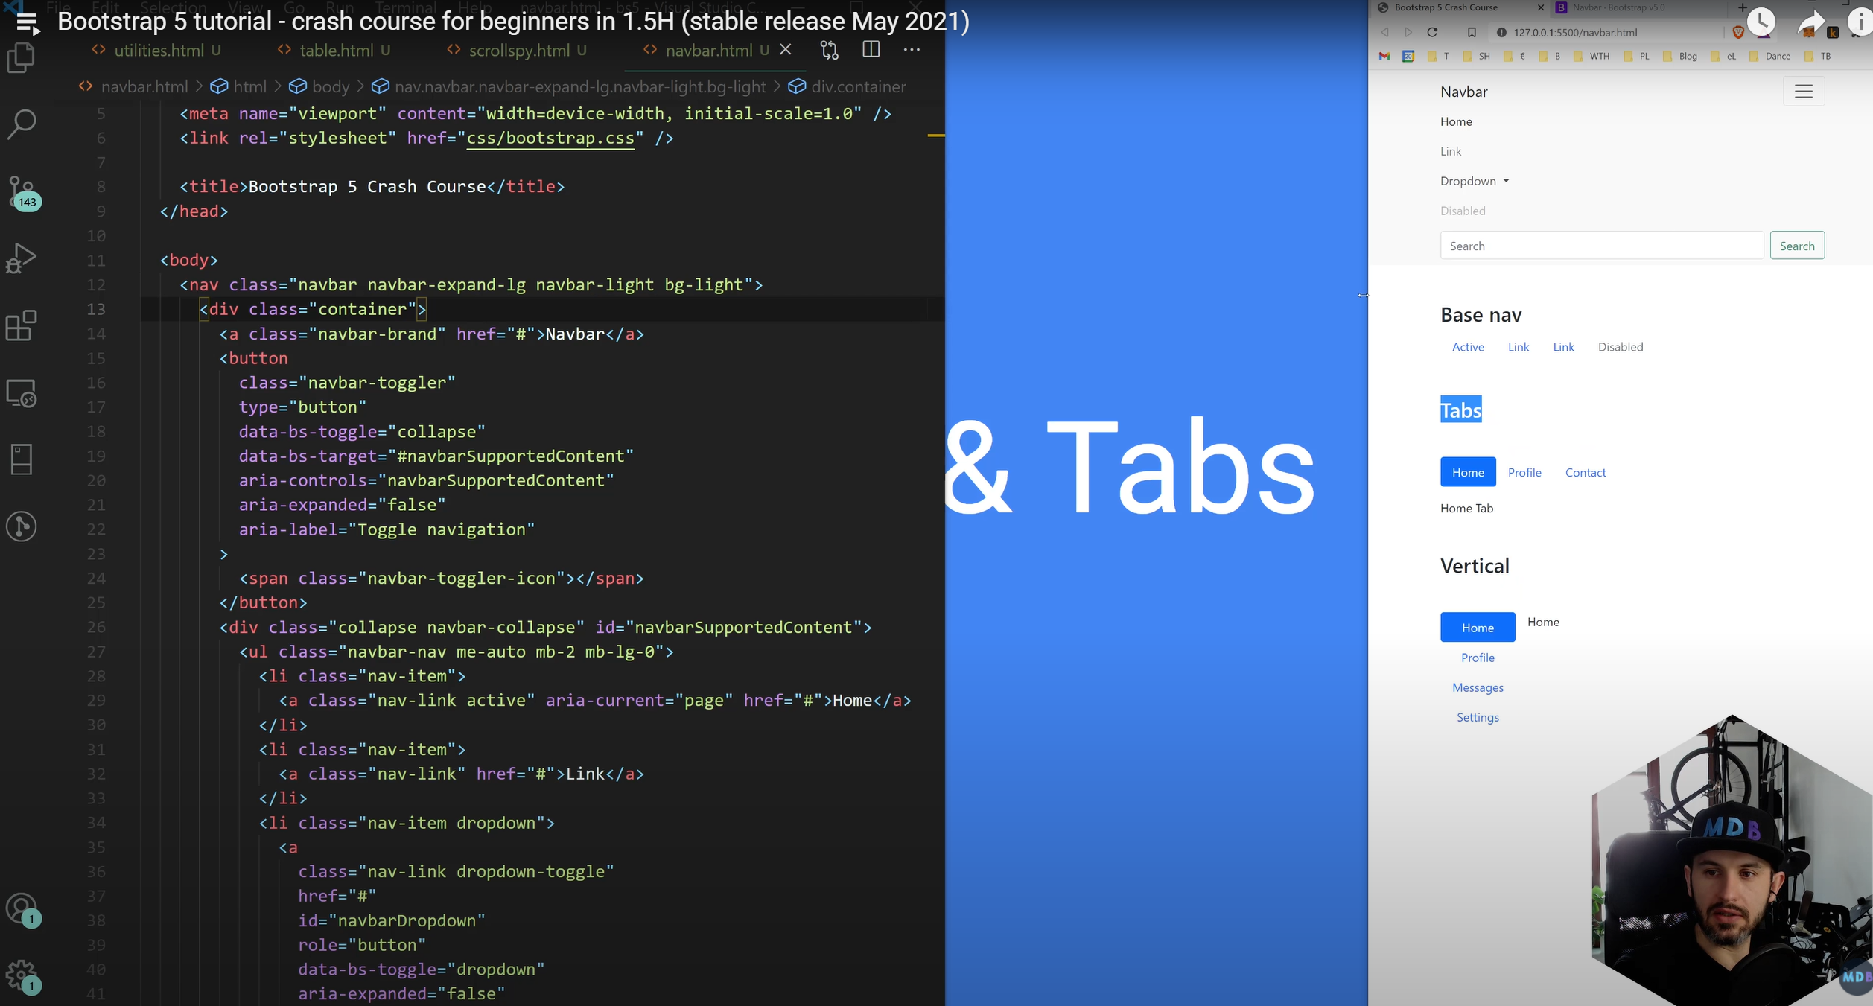

# **Navs (Component)**

**Base Nav similar to navigator tab**

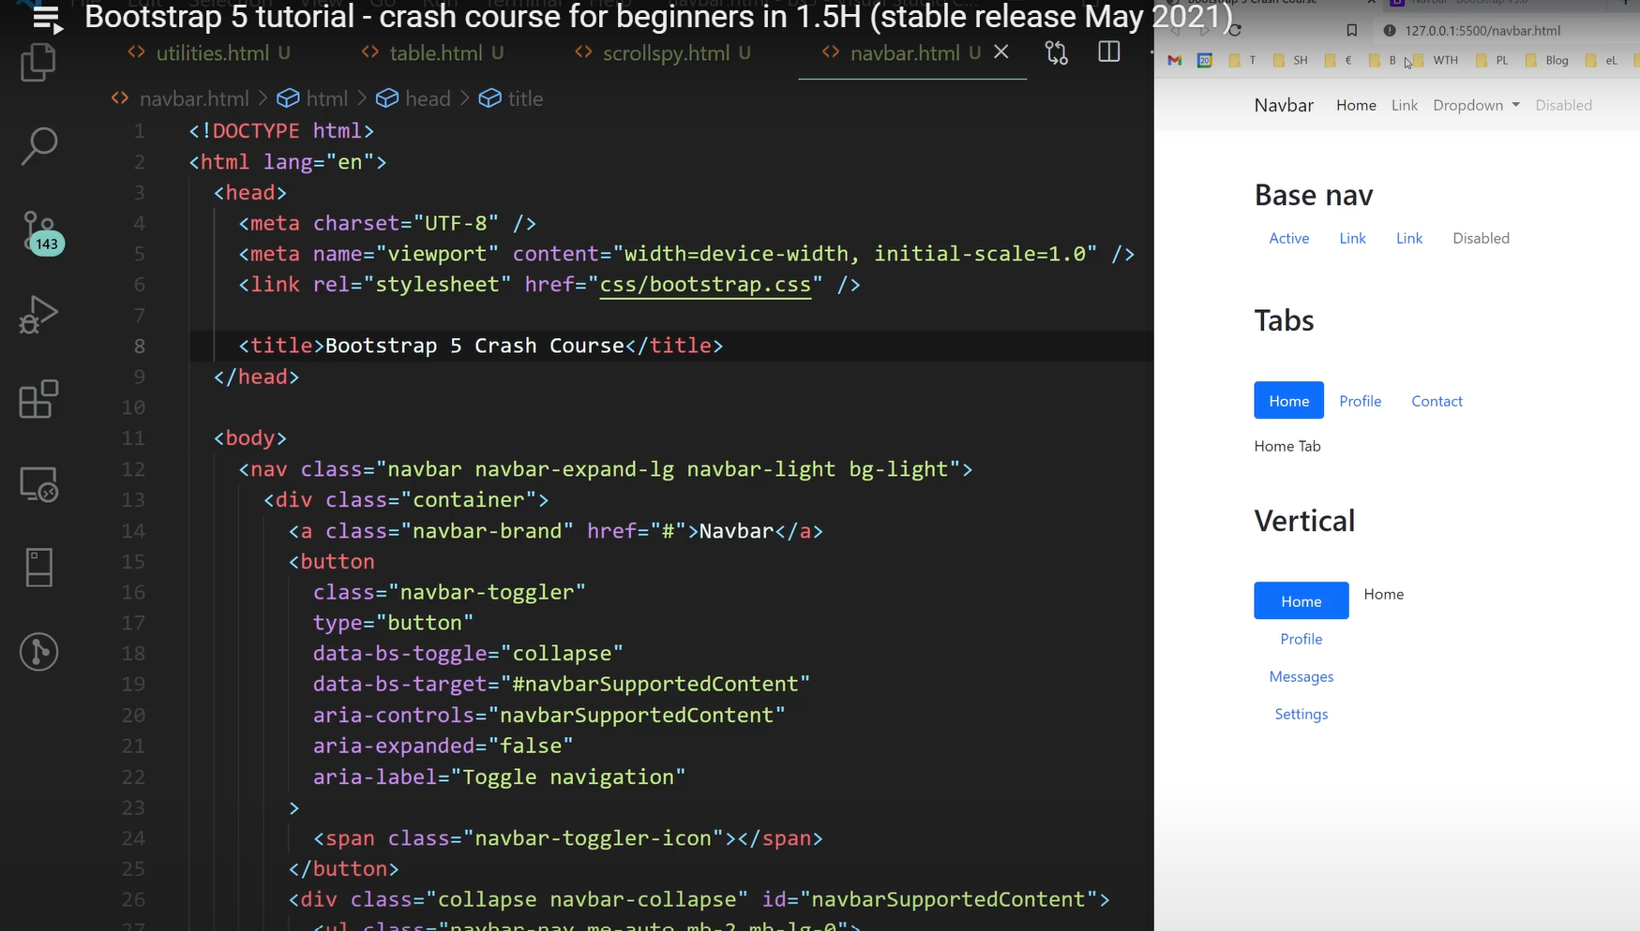

# **Tabs**

# **Vertical Tabs**

# **Offcanvas (Component) – Popout sidebar nav bar (new for v5.0)**

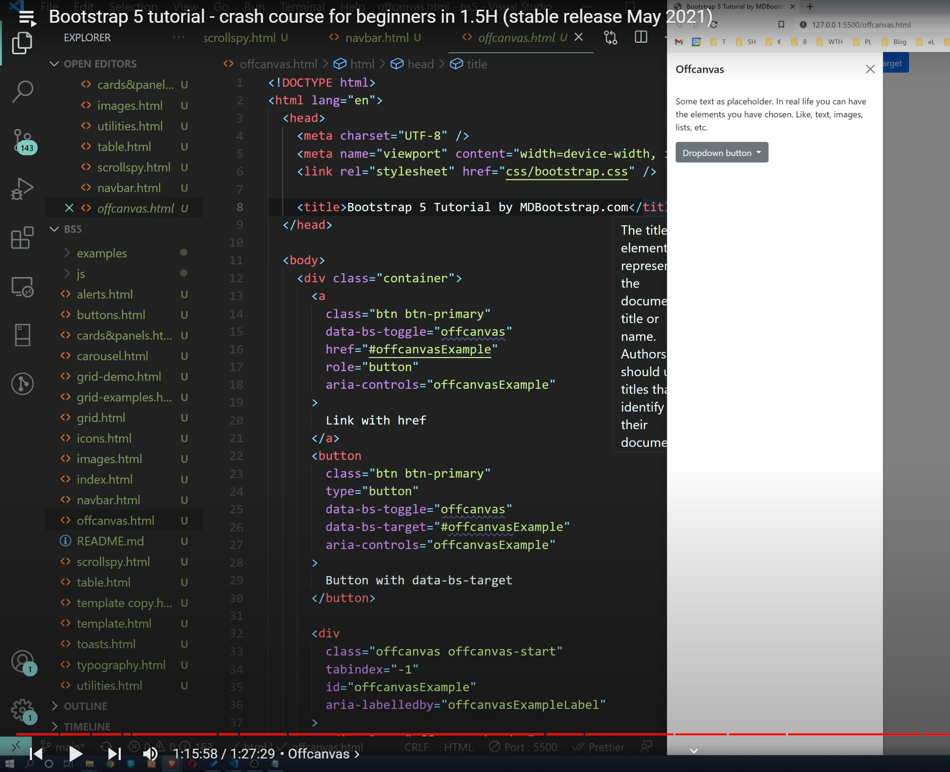

# **Icons (Extend)**

Can be combined with buttons

Docs: [Icons · Bootstrap v5.1 (getbootstrap.com)](https://getbootstrap.com/docs/5.1/extend/icons/)

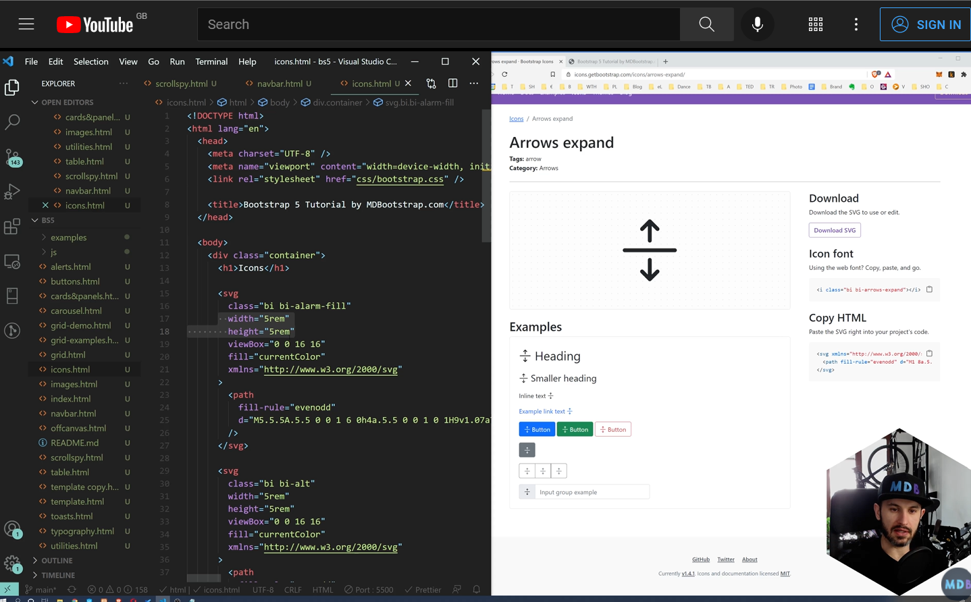

# **Forms (Forms) – Can validate**

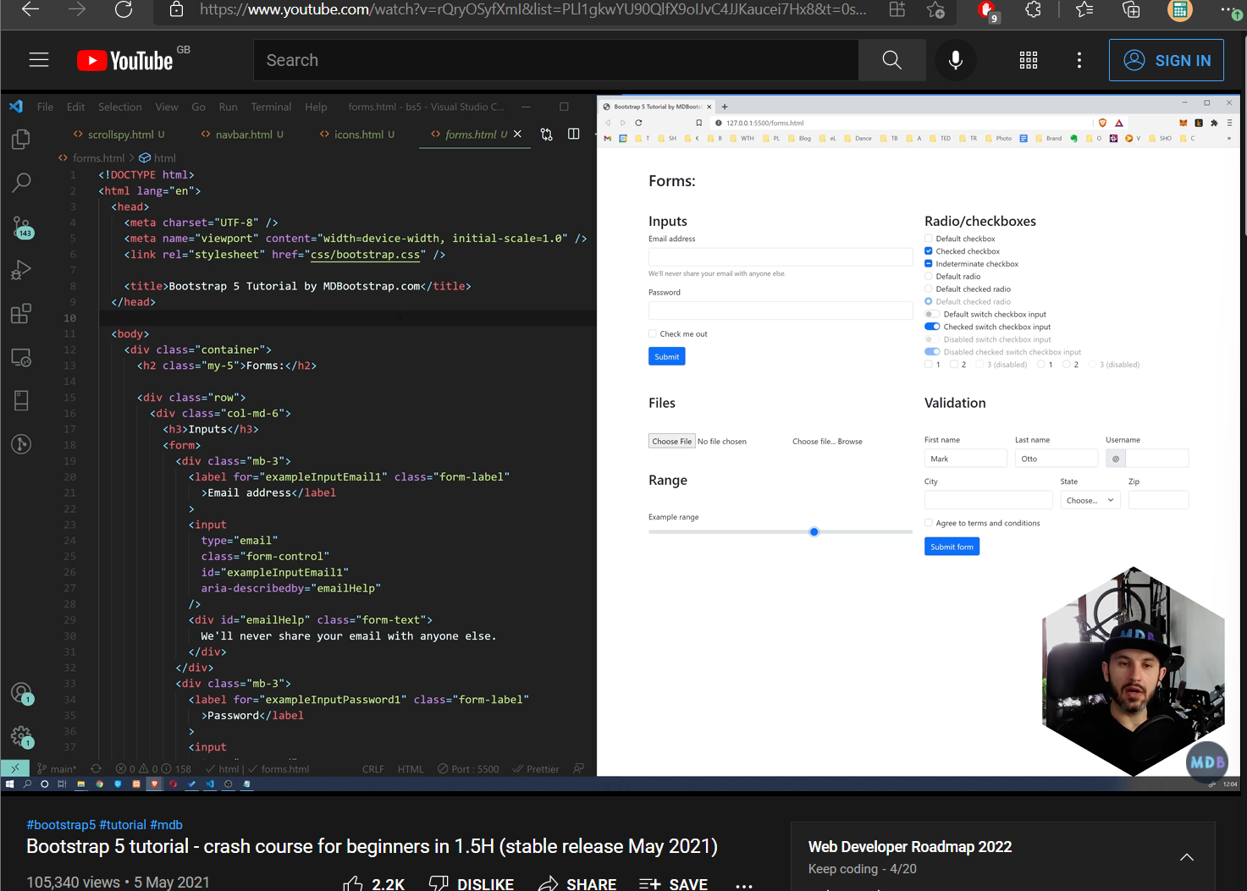

# **Remaining Components (watch 1h:20 min)**

## Accordion (Component) – Expands information tabs (I.e. FAQ)

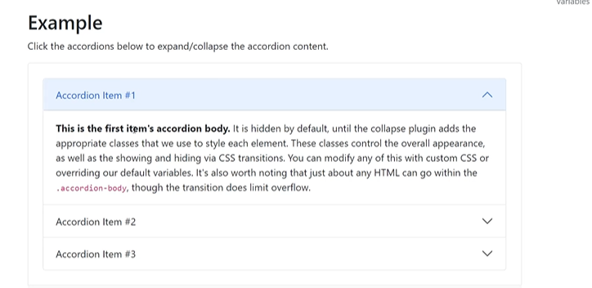

## Badges

## Breadcrumbs (shows where you are going deeper into the page)

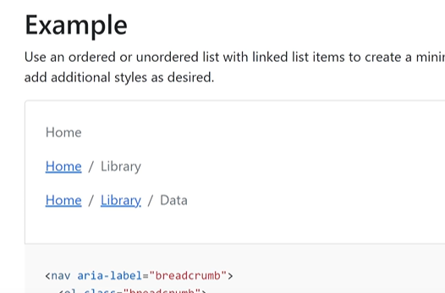

## Collapse (Close or open multiple dips at the same time)

## Collapses a button or (<div></div>) when you press it

## Models (Simple, similar to a card, pop up window, very useful, dark background, cofus attention)

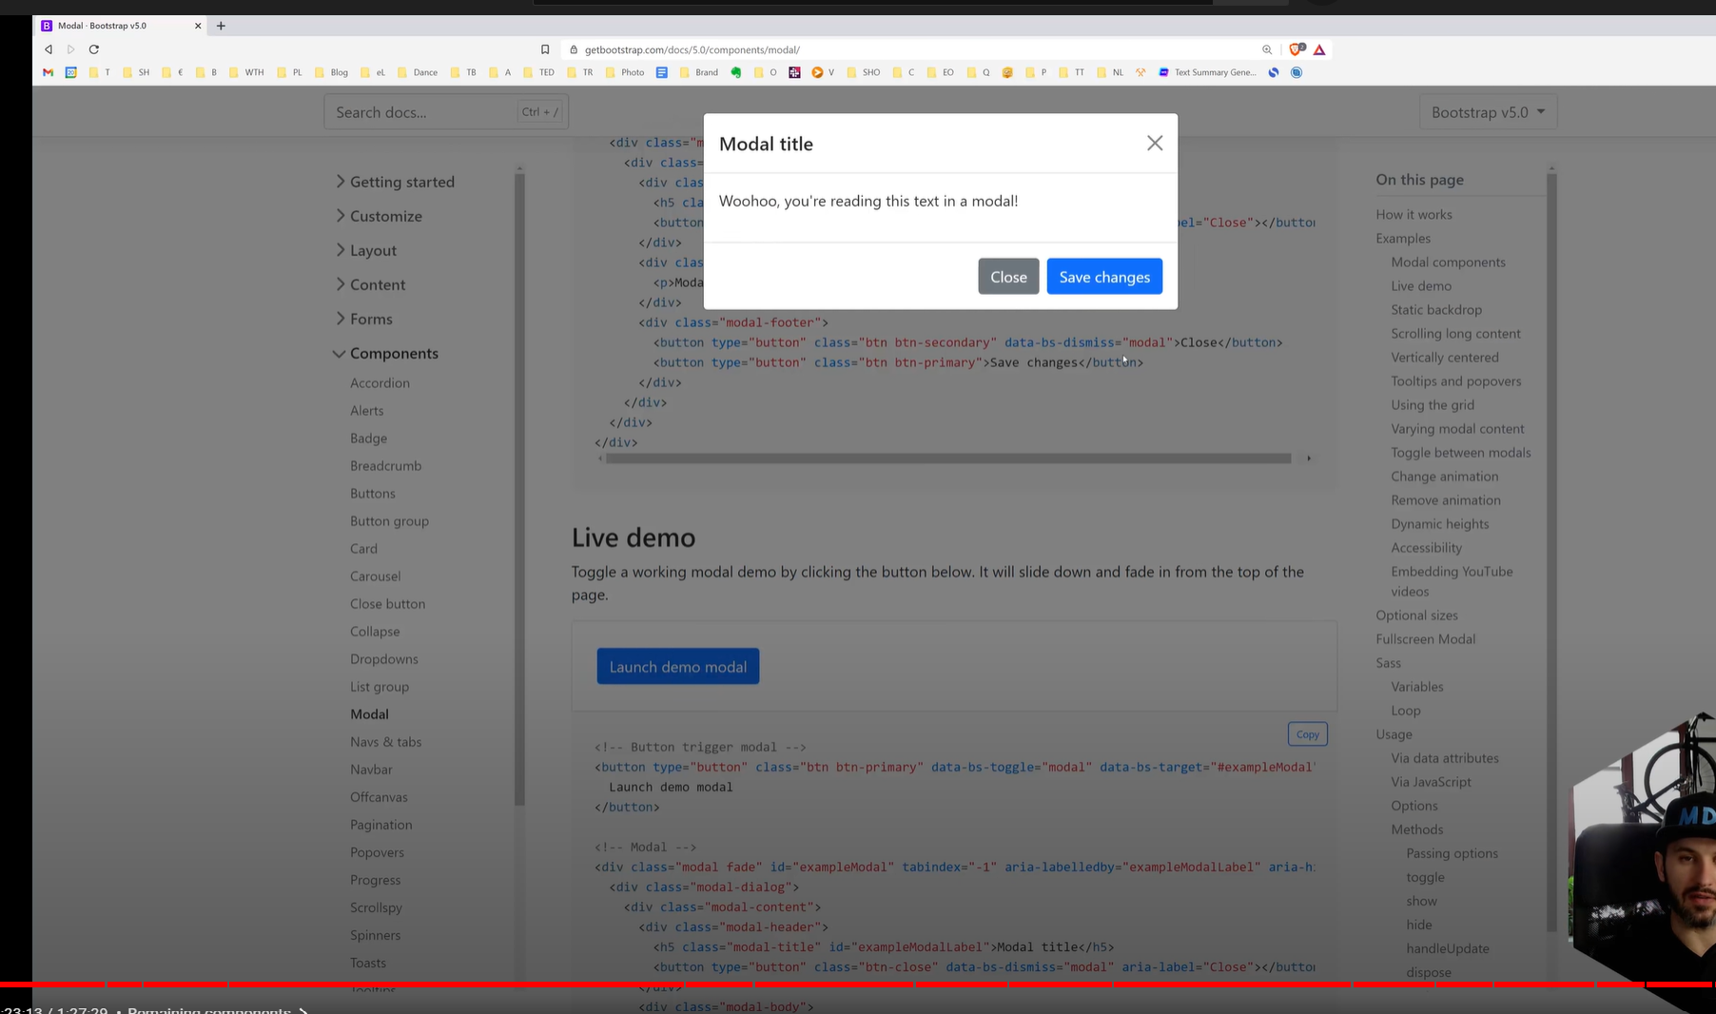

## **Popovers (popout window when you click a button, the window remains open)**

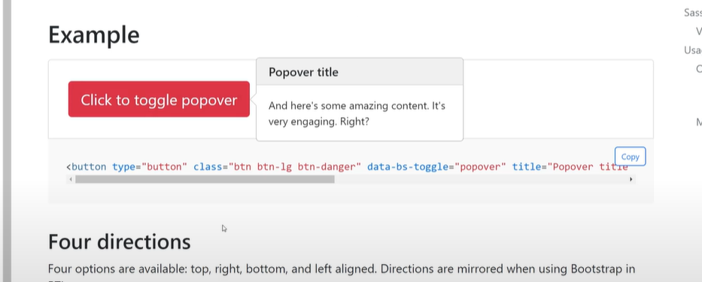

## **Tooltips (Popout window, hover over a button, automatically disappears)**

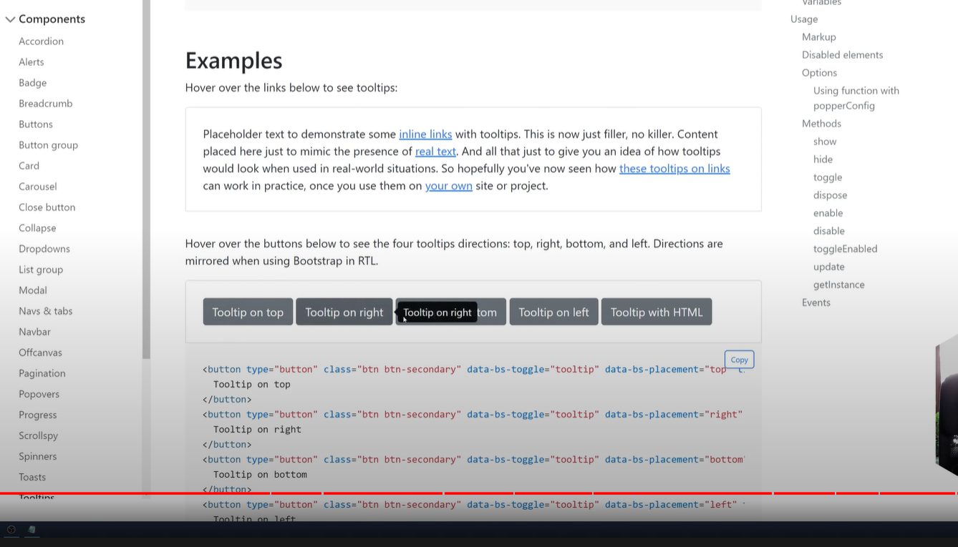

Progress bars (Give feedback that something is loading)

Spinner (Give feedback that something is loading)

# **Helpers**

Allow us to modify our html so it looks prettier

## **Clearfix**

Docs: [Clearfix in Bootstrap - GeeksforGeeks](https://www.geeksforgeeks.org/clearfix-in-bootstrap/)

Bootstrap: [Clearfix · Bootstrap v5.1 (getbootstrap.com)](https://getbootstrap.com/docs/5.1/helpers/clearfix/)

Prevents the child div inside parent div, the child div automatically flows around the parent div. The solution to this problem is using clear property of CSS.

Bootstrap allows us to use a class named clearfix which is used to clear the floated contents inside any container.

Example 1: Without clearfix property. In the below program two buttons are floated to left and right.

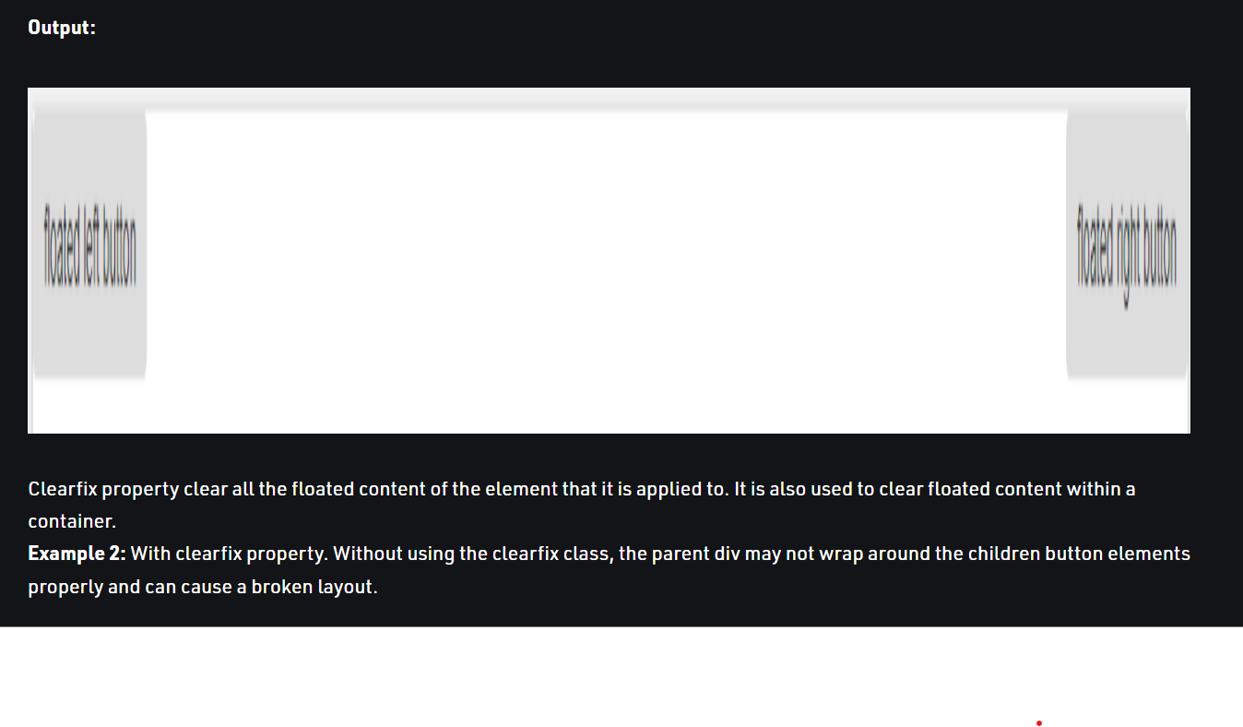

**After:**

# **Starter Template**

**COPY THE STARTER TEMPLATE TO YOUR HTML TEMPLATE**

***It will import the CSS (Caseated Style Sheet) and java script (providing the functionality for each page (i.e. actions, clicking etc.).***

[Introduction · Bootstrap v5.1 (getbootstrap.com)](https://getbootstrap.com/docs/5.1/getting-started/introduction/)

Downloads all the code that is necessary for you to use bootstrap, within html allowing us to creater nicer styles.

